# EMPLOYEE TRAVEL APPROVAL APPICATION FOR CORPORATES

1. **INTRODUCTION**
   1. **OVERVIEW:**

Travel approval means approval of official travel in advance by an appropriately delegated officer, utilizing the appropriate form of system. Some examples of common types of business travel include travelling to a different branch of the same company, travelling to a different location to meet suppliers or business partners, or travelling for a conference or business events.

* 1. **PURPOSE**
* **Cutting down on the travel expenses:** cutting down costs is a challenge for most processes. A lot of factors lead to budget overspending at your company. Firstly, employees might not be getting access to affordable travel options. Secondly, ever if they get affordable options, they might not willing to book it. Last minute bookings and unclear travel policies can be sonme ot6her reasons.
* **Lack of 24/7 support:** consider the situation where an employee goes on a business trip and is denied check in at the hotel. The employees call the TMC but gets no response as it is beyond their working hours. It will affect the employees as 3well the work.
* **keeping employees data secure :** one of the major challenges in corporate travel management is keeping business data secure. Managing business travel involves storing and processing a lot of critical information like employee’s personel identifiable information, credit card information, and travel arrangement such data can cause financial loses to the company and threaten employees security if leaked.

1. **Problem definition and design thinking:**
   1. **empathy map**

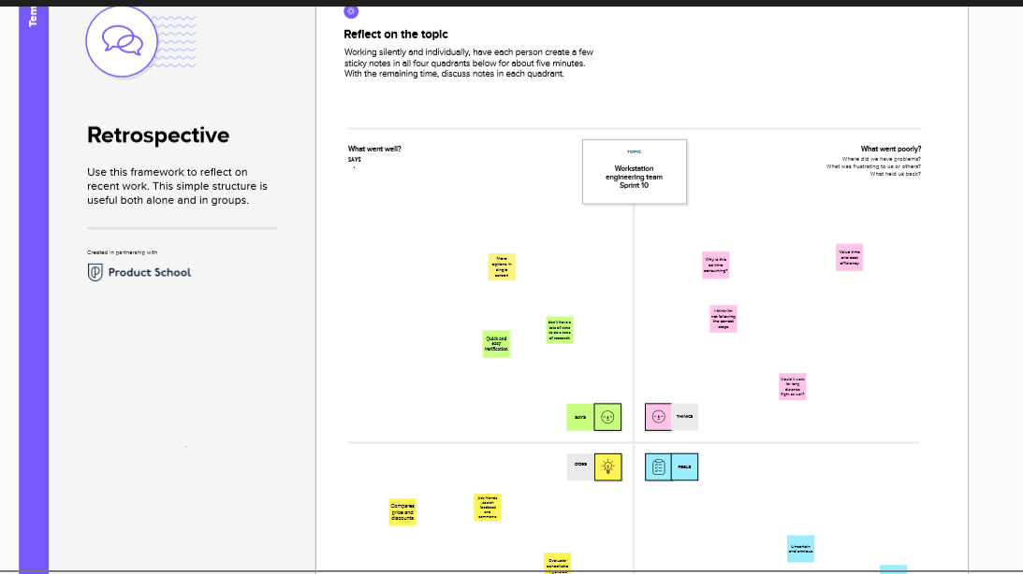

.**2.2 Brain storming map:**

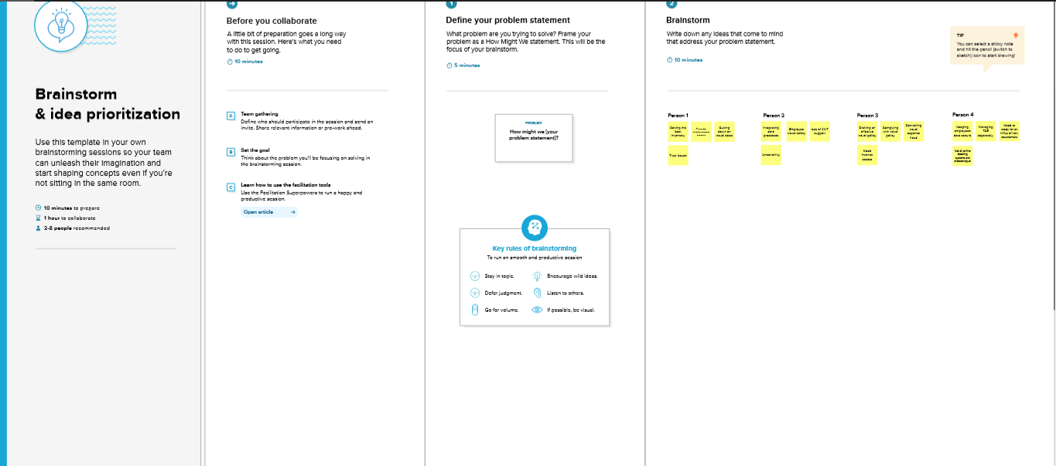

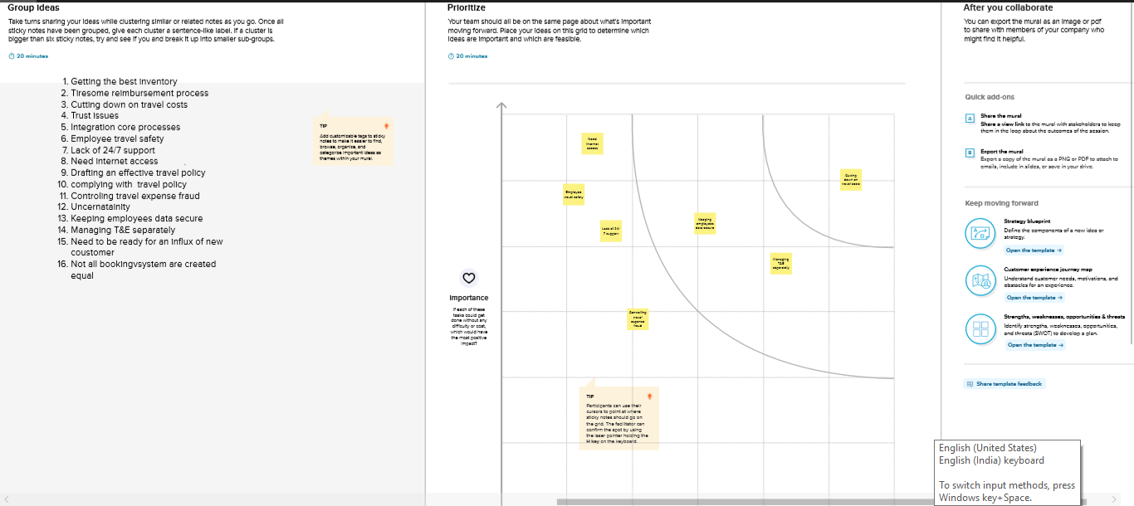

**3. RESULT**

**3.1 Data model**

|  |  |
| --- | --- |
| **Object name** | **Field in the object** |
| **Fields & Relationship** | |  |  | | --- | --- | |  | | | **Field label** | **Data type** | | Data type | Currency | | Field label | Amount | | Length | 16 | | Decimal place | 2 | |
| **Users and setup approvals** | |  |  | | --- | --- | |  | | | **Field label** | **Data type** | | First name | Harigha | | User name | harigha@company .com | | Role | CEO | | Profile | Administrator | | License | Salesforce | |
| **Validation rule** | |  |  | | --- | --- | |  | | | **Field label** | **Data type** | | Rule name | Trip end date after start date | | Condition formula | Trip _end_date_c<Trip_start_date_c | | Error message | Trip and date must be greater than or equal to start date | |
| **Roll up summary fields** | |  |  | | --- | --- | |  | | | **Field label** | **Data type** | | Label | Total expenses | | Name | Total_expenses | | Summarized object | Expenses items | | Roll up type | SUM | | Field to aggregate | Amount | |

**3.2 Activity & Screenshot :**

**1. Custom tab**

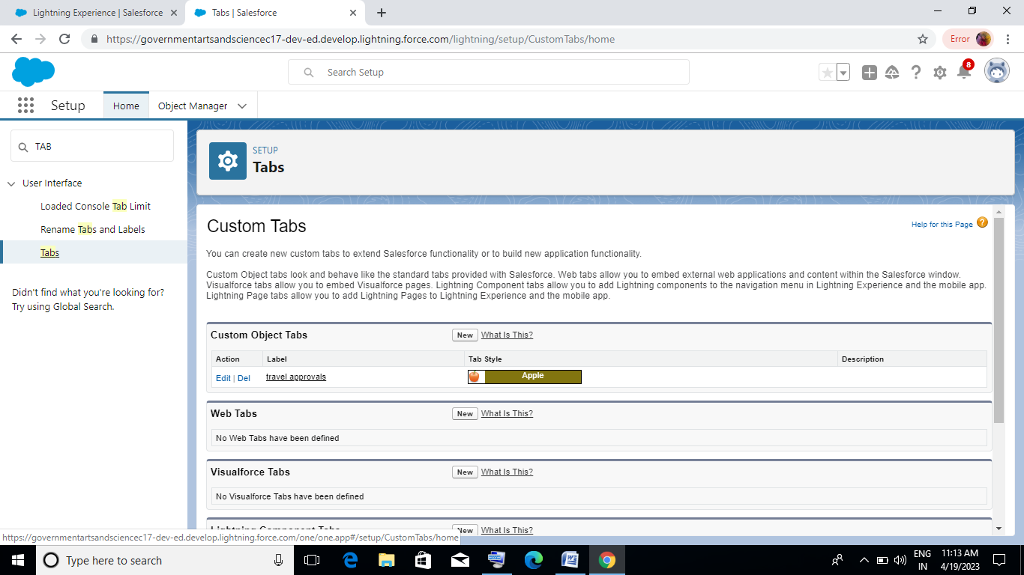

**2. Report**

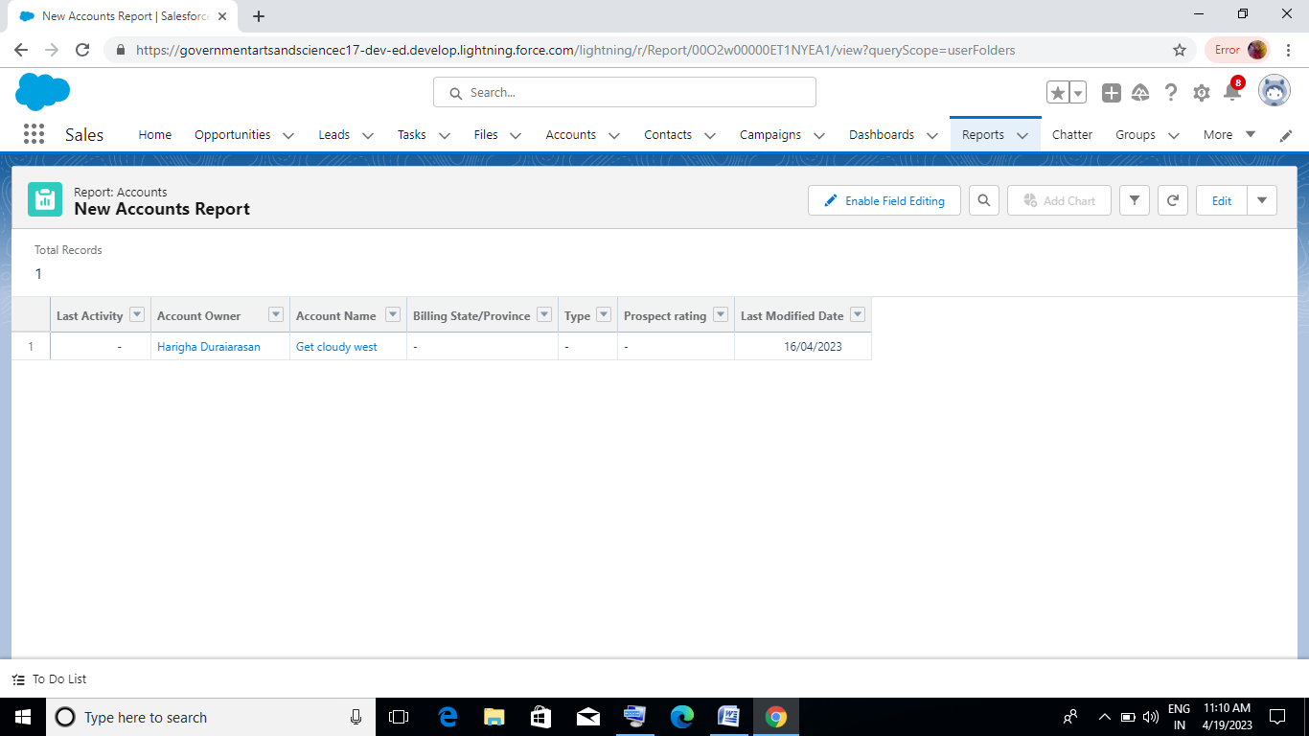

**3.Account**

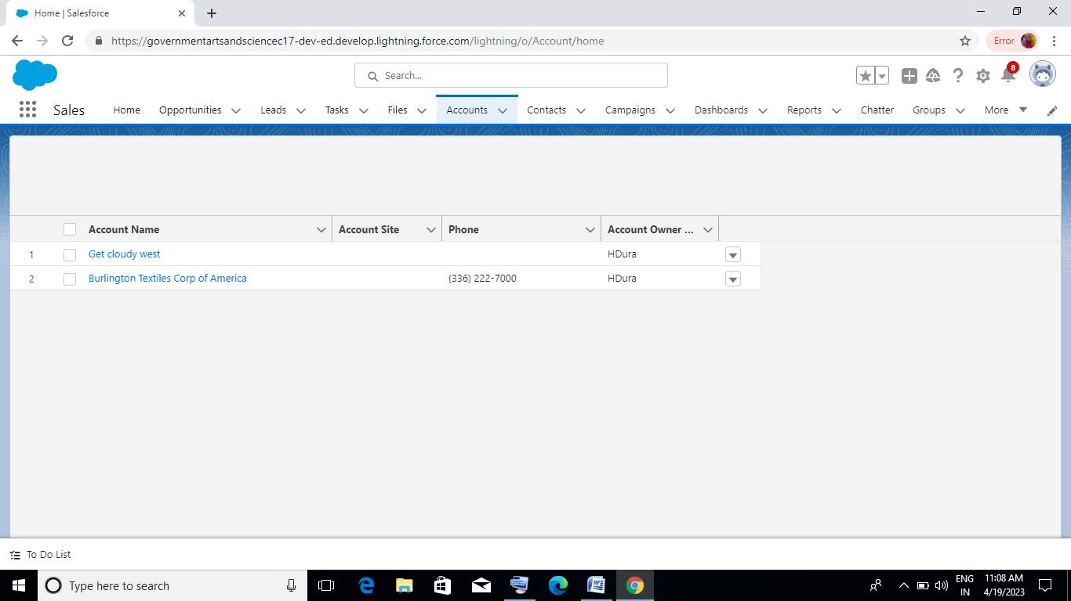

**4.Dashboard**

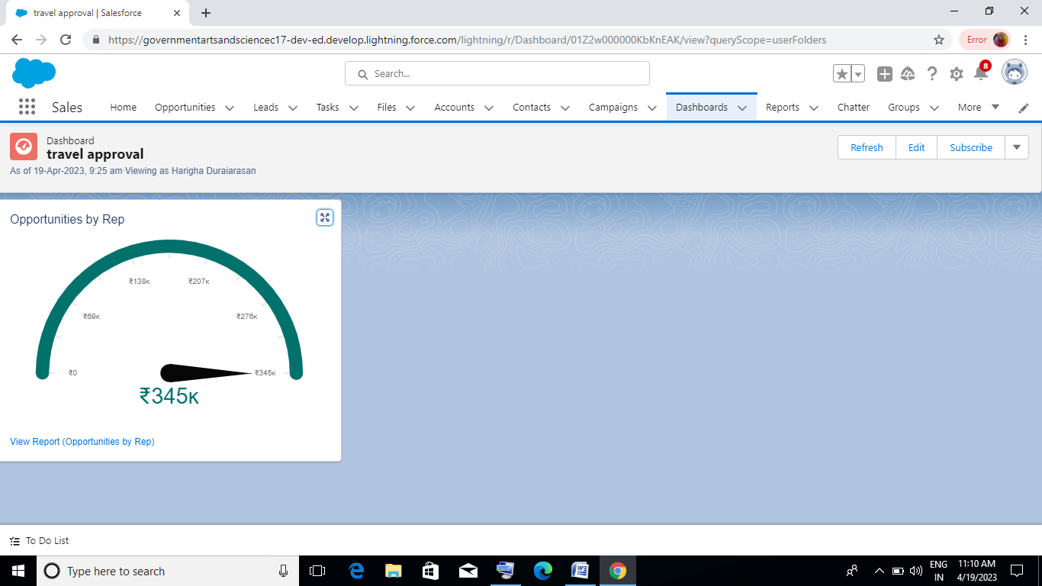

**5. Object**

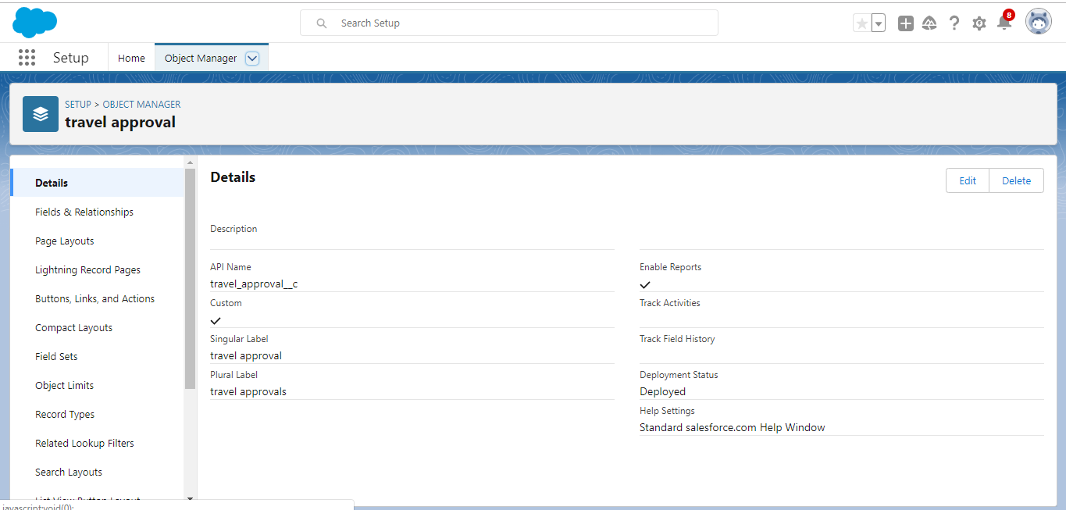

**6. User**

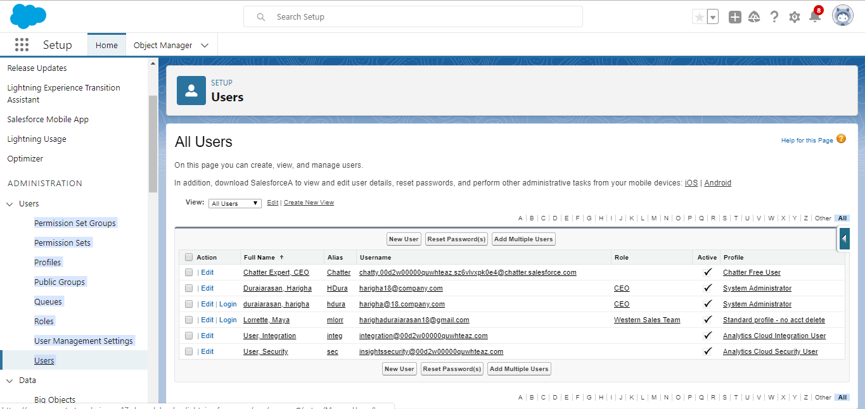

**4.Trailhead profile public URL :**

**Team lead -** [**https://trailblazer.me/id/hduraiarasan**](https://trailblazer.me/id/hduraiarasan)

**Team member 1 –** [**https://trailblazer.me/id/hramesh20**](https://trailblazer.me/id/hramesh20)

**Team member 2-** [**https://trailblazer.me/id/jvengateshan**](https://trailblazer.me/id/jvengateshan)

**Team member 3-** [**https://trailblazer.me/id/kkaruppaiya2**](https://trailblazer.me/id/kkaruppaiya2)

**5. Advantages & Disadvantages**

**Advantages :**

* **Getting best inventory.**
* **Cutting down on travel costs.**
* **Controlling travel expenses fraud.**
* **Managing T&E separately**

**Disadvantages :**

* **Lack of 24/7 support**
* **Travel safety**
* **Tiresome reimbursement process**
* **Integrating core processes**

**6. Application:**

**Travel approval application :**

* **About the sample application.**
* **Prerequisites.**
* **Installing the sample application .**
* **Defining the use of on external web browser .**
* **Starting the sample application .**
* **Logging in as an employee for requesting a business trip.**
* **Entering a travel request with flight and hotel information,**
* **Adding additional expanses to your travel request.**
* **Logging in as a manager for approving travel requests.**
* **Approving a travel request.**

**7.Conclution:**

**While the business travel approval process may seem overwhelming when everything is done manually, this doesn’t have to be the case forever. By creating an organized plan , communicating it well, and using an automated, centralized system, you can change the way your company does business travel.**

**8. Scope:**

**This chapter shall apply to all officials and employees in executive branch agencies, whether classified , unclassified or nonclassified , and whether full time , or part time. It shall also apply to all volunteers who are specifically authorized by an executive branch agency to perform service on behalf of the state. If the agency’s agreement with the volunteer specifically provides for the reimbursement of expenses.**